Experiment 13:
Write a C program for implementing a Lexical Analyzer to Count the number of
characters, words, and lines.
Code:
#include <stdio.h>
#include <string.h>
#include <ctype.h>
int main() {
char text[1000];
int characters = 0, words = 0, lines = 0, i;
int inWord = 0;
printf("Enter text (single input, press Enter when done):\n");
fgets(text, sizeof(text), stdin);
for (i = 0; text[i] != '\0'; i++) {
if (text[i] == '\n')
lines++;
if (!isspace(text[i]))
characters++;
if (isspace(text[i]))
inWord = 0;
else if (inWord == 0) {
inWord = 1;
words++;
}
}
printf("\nCharacters: %d\n", characters);
printf("Words: %d\n", words);
printf("Lines: %d\n", lines);
return 0;
}

Output:
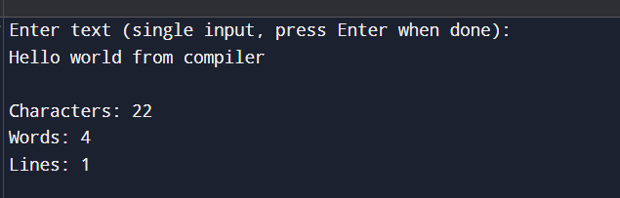

Experiment 14:
Write a C Program for code optimization to eliminate common subexpression.
Code:
#include <stdio.h>
int main() {
int a, b, c, d;
int x_before, y_before;
int x_after, y_after;
printf("Enter values for a, b, c, d: ");
scanf("%d %d %d %d", &a, &b, &c, &d);
x_before = (a + b) - (c + d);
y_before = (a + b) * (c + d);
int t1 = a + b;
int t2 = c + d;
x_after = t1 - t2;
y_after = t1 * t2;
printf("\nBefore Optimization:\n");
printf("x = (a + b) - (c + d) = %d\n", x_before);
printf("y = (a + b) * (c + d) = %d\n", y_before);
printf("\nAfter Optimization:\n");
printf("t1 = a + b = %d\n", t1);
printf("t2 = c + d = %d\n", t2);
printf("x = t1 - t2 = %d\n", x_after);
printf("y = t1 * t2 = %d\n", y_after);
return 0;
}

Output:
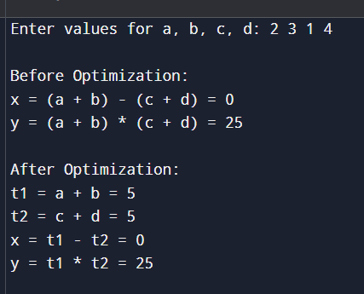

Experiment 15:
Write a C program to implement the back end of the compiler.
Code:
#include <stdio.h>
int main() {
char a, b, c, d;
printf("Enter variable names (a, b, c, d): ");
scanf(" %c %c %c %c", &a, &b, &c, &d);
printf("\n--- Three Address Code ---\n");
printf("t1 = %c * %c\n", c, d);
printf("%c = %c + t1\n", a, b);
printf("\n--- Assembly Code Simulation ---\n");
printf("LOAD %c\n", c);
printf("MUL %c\n", d);
printf("STORE t1\n");
printf("LOAD %c\n", b);
printf("ADD t1\n");
printf("STORE %c\n", a);
return 0;
}
Output:
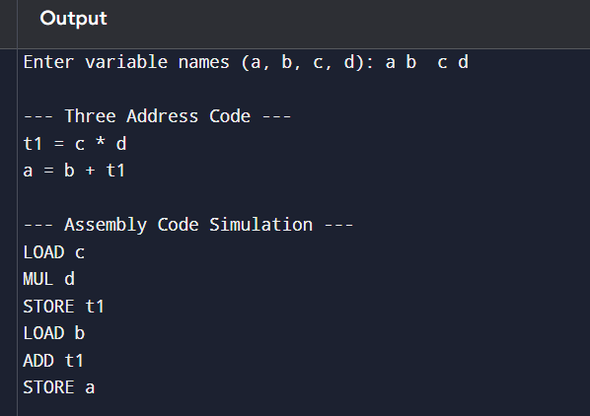
Experiment 16:
The lexical analyser should ignore redundant spaces, tabs and new lines. It should also ignore comments. Although the syntax specification states that identifiers can be arbitrarily long, you may restrict the length to some reasonable value. Write a LEX specification file to take input C program from a .c file and count the number of characters, number of lines & number of words.
Code:
%{
#include <stdio.h>
int characters = 0, words = 0, lines = 0;
%}
%%
[ \t]+ ; /* ignore spaces/tabs */
\n { lines++; characters++; }
[A-Za-z0-9_]+ { words++; characters += yyleng; }
. { characters += yyleng; }
%%
int main(){ yylex(); printf("Characters: %d\nWords: %d\nLines: %d\n", characters, words, lines); return 0; }
int yywrap(){ return 1; }
Input:
#include <stdio.h>
int main()
{
printf("Hello");
}
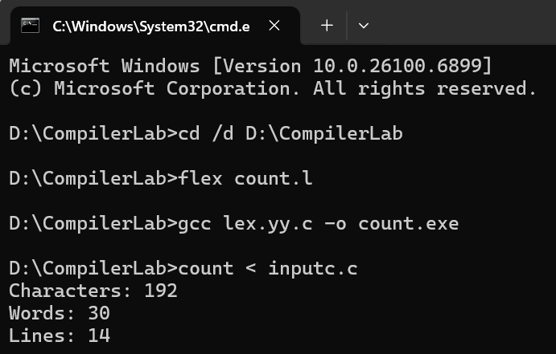
Output:
Experiment 17:
Write a LEX program to print all the constants in the given C source program file.
Code:
%{
#include <stdio.h>
%}
%%
[0-9]+(\.[0-9]+)? { printf("Constant: %s\n", yytext); }
\"([^\\\"]|\\.)*\" ; /* ignore string literals */
.|\n ; /* ignore others */
%%
int main(){ yylex(); return 0; } int yywrap(){ return 1; }
Input:
#define PI 3.14
int x = 30; printf("val %d", x);
Output:
